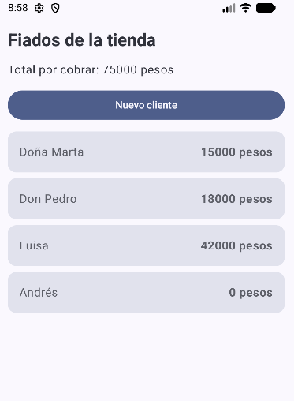https://github.com/SrDaleth/FiadoApp
https://github.com/SrDaleth/FiadoApp